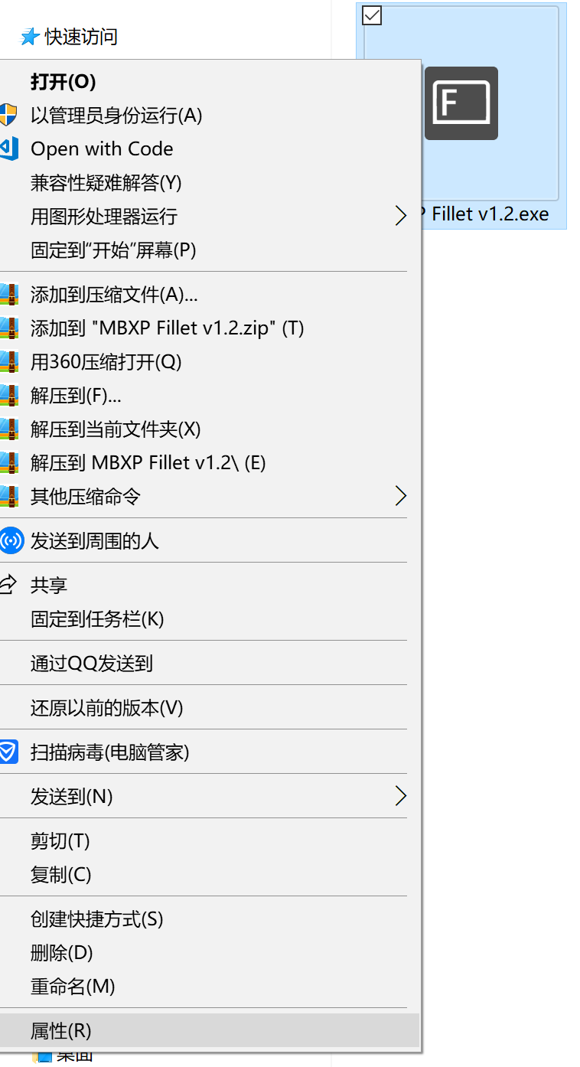

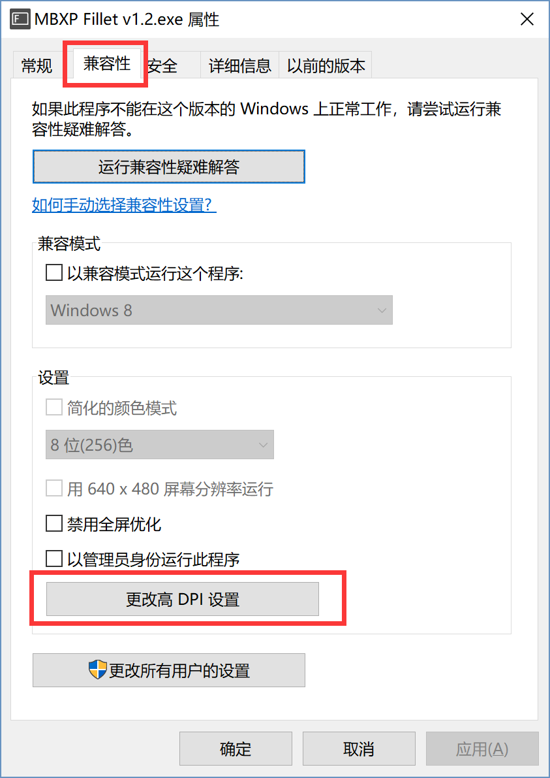

1. Select ”program”

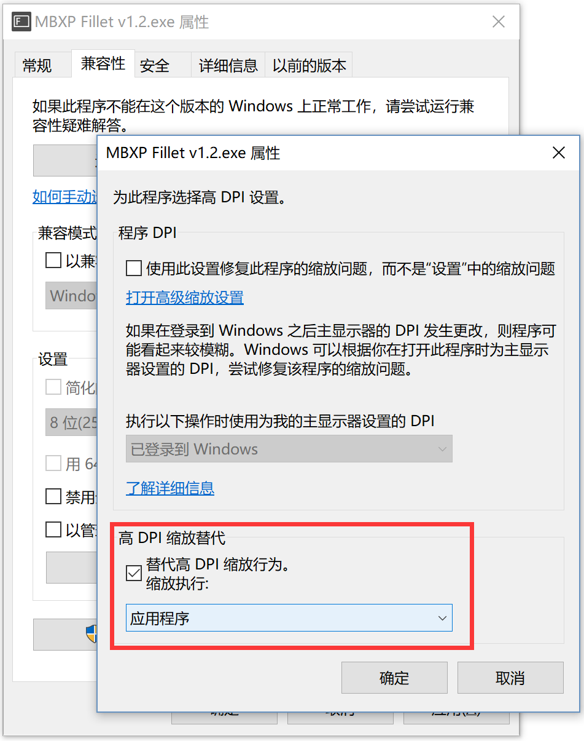

-------------------------------------------------------------------------------

before：



after：

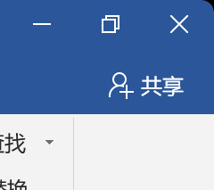

How to boot automatic startup?

Put the program in “Programs” folder

…\AppData\Roaming\Microsoft\Windows\Start Menu\Programs